300986134 Parth chandgadhiya

Chapter 8 hands on

Answer 1





Answer 2

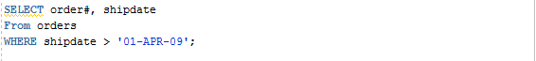

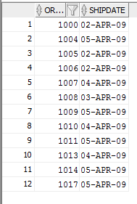

Answer 3



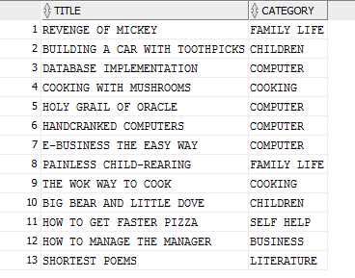

Answer 4

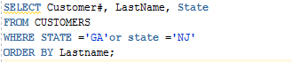

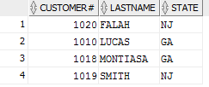

## Or

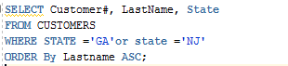

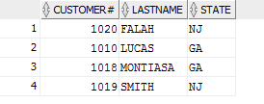

Answer 5



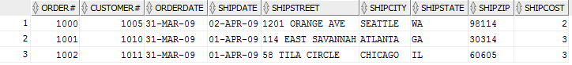

Answer 6

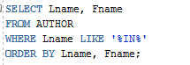

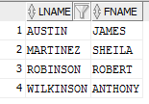

Answer 7



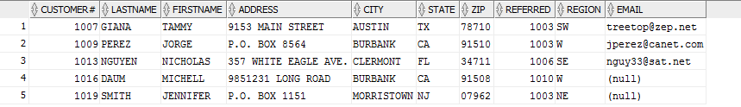

Answer 8

# a)



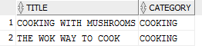

# b)



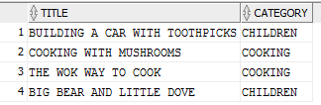

# c)

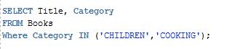

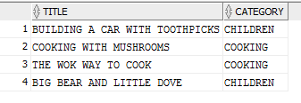

Answer 9

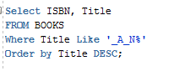



Answer 10

# A)

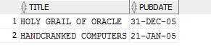

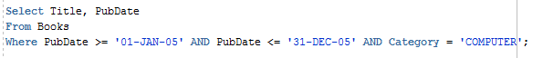

# b)

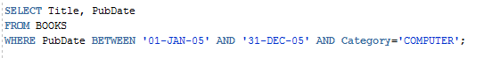

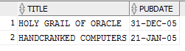

# c)

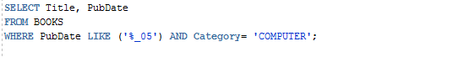

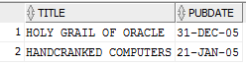

CODE

SELECT title, category

from books

where category <> 'FITNESS';

SELECT Customer#, LastName, State

FROM CUSTOMERS

WHERE STATE ='GA'or state ='NJ'

ORDER By Lastname ASC;

SELECT *

FROM ORDERS

WHERE orderdate <'01-APR-09';

SELECT Lname, Fname

FROM AUTHOR

WHERE Lname LIKE '%IN%'

ORDER BY Lname, Fname;

SELECT *

FROM customers

WHERE referred IS NOT NULL;

Select Title, category

From Books

Where Category = 'CHILDRE' OR Category = 'COOKING';

Select Title, Category

From Books

Where Category LIKE ('CH%') OR Category LIKE ('CO_K%');

SELECT Title, Category

FROM Books

Where Category IN ('CHILDREN','COOKING');

Select ISBN, Title

FROM BOOKS

Where Title Like '_A_N%'

Order by Title DESC;

Select Title, PubDate

From Books

Where PubDate >= '01-JAN-05' AND PubDate <= '31-DEC-05' AND Category = 'COMPUTER';

SELECT Title, PubDate

FROM BOOKS

WHERE PubDate BETWEEN '01-JAN-05' AND '31-DEC-05' AND Category='COMPUTER';

SELECT Title, PubDate

FROM BOOKS

WHERE PubDate LIKE ('%_05') AND Category= 'COMPUTER';